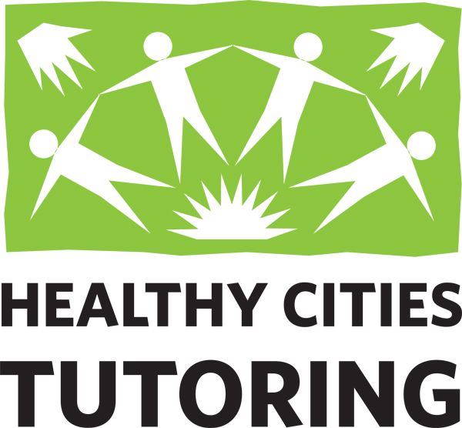 Employment Opportunity

Organization: HEALTHY CITIES TUTORING
Position: Program Coordinator- Part-time (25 hour/week)
Reports to: Program Manager

About the Position
Healthy Cities Tutoring is seeking a community-minded applicant wanting to make a difference in the lives of children as a Program Coordinator. This position reports to the Program Manager and is responsible for coordinating our tutoring program at San Carlos and Redwood City schools. Program Coordinators make and maintain matches between students identified by school staff as needing academic support with volunteer tutors who have been approved through our screening process.

Other tasks include community outreach, tutor recruitment, program communications, and general administration duties as an integral member of the Healthy Cities Tutoring staff.

This is a part-time position of 20-30 hours per week depending on workload for 45+ weeks a year following a standard academic calendar. Must be able to work varied hours during the school year and travel between school sites for meetings and tutor/student introductions.

Values
- Be a positive, professional representation of HCT to all potential program participants
- Promote HCT and its mission in the schools and with the broader community
- Efficiently conduct HCT operations to maximize non-profit resources

About Healthy Cities Tutoring
Healthy Cities Tutoring (HCT) believes every student can succeed with support. With the help of dedicated community volunteers, Healthy Cities provides one-on-one tutoring and mentoring to students who find school challenging. HCT tutors support over 500 students at 14 public schools in San Carlos and Redwood City, California.

Essential Duties:
- Build and maintain positive working relationships and communication with teachers, administrators, parents, volunteers, and tutors at assigned school sites.
- Recruit, match, and support volunteer tutors working with K-8th grade students.
- Lead and work closely with Volunteer Site Coordinators at assigned schools to match tutors with students, considering student needs, tutor preferences, teacher requests, and availability.
- Maintain spreadsheets, information, and files as appropriate for each assigned school to ensure all data is current, well organized, and accessible.
- Represent Healthy Cities Tutoring and speak about the program’s mission at community and school-related events throughout the year (i.e., PTA/PTO meetings, MAZE Days, Service Clubs, Chamber of Commerce meetings, Booths at Farmers Markets & community events, etc.)
- Assist with annual volunteer recognition events and fundraising campaigns as needed.
- Contribute ideas and content for newsletter articles, Annual Report, and Social Media posts.
Qualifications
- Proficiency in Google Suite (Docs, Sheets, Slides, etc.) required.
- Demonstrated ability to communicate clearly with parents, school site staff and volunteers.
- Ability to work with a diverse clientele in an empathetic, non-judgmental manner.
- Ability to problem-solve, integrate feedback, and utilize supervision.
- Excellent interpersonal skills, able to function as part of a collaborative team with colleagues, volunteers, and outside partners and organizations.
- Background check, including fingerprint clearance from the Department of Justice required.
- Bachelor’s degree preferred, or equivalent combination of education and experience in a related field.
- Experience in education, the human services sector, and volunteer coordination is a plus.
- Previous tutoring experience is a plus but not required.
- Bilingual – English/Spanish familiarity or fluency is a plus.

In addition, the candidate will need to:
- Work a few nights and weekends to support training workshops and community events.
- Provide own car, insurance, valid driver’s license, or other means to travel throughout the San Carlos and Redwood City area.
- Have full range of motion and be able to lift 20 lbs. when setting up our outreach booth (table, canopy, chairs, materials, etc.) at events.

Note: If you do not have the exact experience or skills but think you would be a great fit, please apply for the role. We are looking for more than what a resume can show.

Deadline for applications: Accepting resumes June 20, 2022, until the position is filled.

Compensation​​:
- Range $24 -$29 per hour based on experience
- Benefits: Paid sick leave, flexible scheduling, cellphone stipend, and CalSavers Retirement Savings Program
- School vacations off and limited work schedule during the summer months (negotiable)

Confidential Application Process:​​ Email your cover letter summarizing your interest and experience and your current resume to Karen Molinari, Executive Director, at karen@healthycitiestutoring.org with “HCT Program Coordinator Search” in the subject line. ​​​ Please visit www.healthycitiestutoring.org for more information.

HCT is an Equal Opportunity employer. Applicants are considered without regard to race, color, religion, creed, national origin, age, sex, gender, marital status, sexual orientation, identity, genetic information, veteran status, citizenship, or any other factors prohibited by local, state, or federal law.

